# chapter 3: system analysis and design

### 

## 3.1.1 Requirement Specification

### i. Functional Requirement

* The system shall have different account student, teacher and admin.
* The system shall be role-based permissions and profile updates.
* Educator and admin shall be able to see activities of student.
* Admins, and teacher shall be able to create, delete and update the event.
* Students shall save the report for the further uses.
* Students shall submit their assignment

Use-Case Diagram

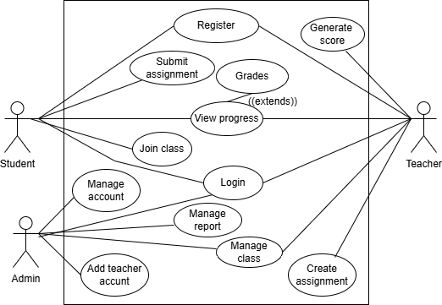

**Figure 1 Use-Case Diagram of EDP**

### ii. Non-functional Requirement

* The system must have user-friendly UI.
* The system must be secured.
* The system must be compatible

these costs with the available budget, and analyzing the potential return on investment to ensure the project is financially sustainable.

**iv. Schedule**

The project is scheduled in following way:

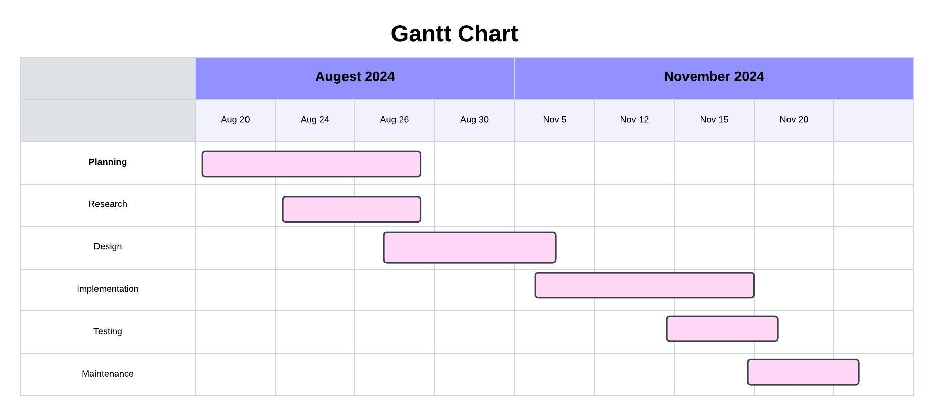

Figure 2 Gantt Chart of EDP

### 3.1.3 Data Modelling

Figure 3: ER-Diagram of EDP

### 3.1.4 Process Modelling (DFD)

1. Level-0/Context Diagram

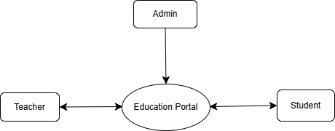

Figure 4: Level-0 DFD of EDP

1. 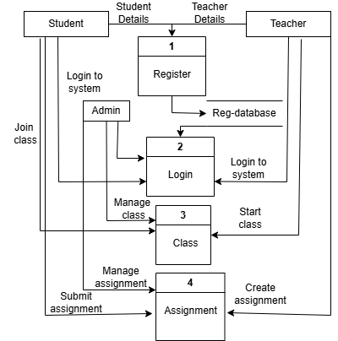 **Level-1**

Figure 5: Level-1 DFD of EDP